Practitioner Issues in Behavior Analysis SIG
Meeting Minutes
ABA:I 2008
Date of Meeting: May 26, 2008

Present:

Joseph Cautilli, Michael Dorsey, Amanda Kelly, Regina Claypool-Frye, Barbara Byers, Craig Thomas, Kathy Charonec, Michael Weinberg.

Meeting called to order at 7:30 by Joseph Cautilli, who was the current SIG Chairman
Chair status handed to Michael Weinberg per Bylaws.
Joseph Cautilli became ex-officio.
Co-Chair and International Representative – Michael F. Dorsey

Other officers identified:
Amanda Kelly – member-at-large
Regina Claypool-Frye – Secretary
Kathy Charonec – Treasurer
Barbara Byers – Family representative

The group reviewed the polling questions previously posted and voted upon for current status and/or actions for each.
Below is a summary of status or action for each item by number and short description. Detailed content can be viewed online.

- Formal letter supporting licensure was completed. Yes vote of 93.3%
- Exempt SIG Chairs from paying SIG Dues: NO vote of 70.59%
- Post Convention Institute – letter sent to Maria Mallott. Yes vote of 75%
- Bylaws committee – completed. Yes vote of 100%
- Member dues– deferred until next year. Yes vote of 77.78%
- Dues ranges – deferred. Highest range vote - $21 - $40.00 – 43.75%
- Bridging studies – deferred. Yes vote of 87.50%
- Adopt behavior analyst model licensing act. Yes vote of 71.43%
- Endorsing private insurance funding. Michael Dorsey to write letter by 7/1/08. Yes vote-100%
- Adopt position statement opposing CMS discontinuation of habilitation service funding. Joe Cautilli to write and sent letter by 7/1/08. Yes vote – 100%
- Pamphlet series – tabled. Yes vote 82.35%
- Petition to allow survey of ABAI membership. Declined by ABAI. Yes vote – 100%
- Consumer and family rep. offices on PIBA SIG board. Approved and assigned.
Yes vote – 73.33%
- Create behavior analytic faculty and funding programs. Tabled. Yes vote – 77.78%
- Create an international chair post on the board – done. Assigned to Michael Dorsey.
Yes vote – 58.82%
- Formal position on APA Model Licensing ACT. Letter on website. M. Dorsey and T. Zane writing article by 9/1/08 and will post to PIBA SIG site. Yes vote 85.71%
- Use of dues to help local chapters educate public re: behavior analysis services. Tabled.
Yes vote 82.35%
- Create committee on linkage of current research into clinical practice. Subcommittee assigned- Joe, Regina on the committee. Yes vote of 88.24%
- Issue practice guidelines. Request for volunteers to work on this committee to be posted by M. Weinberg by 7/1/08. Yes vote = 88.89%
- Creation of “white papers” for the SIG. motion passed. Being worked on by Amy Weinstock and others interested.

Other business discussed:

Two policy lists: Public policy in behavior analysis and the BAO SIG
Craig T. to set up online application with fee for new SIG members
Craig T. suggests mirroring Yahoo info on the BAO site and delete the yahoo group. Options
being investigated and he will get back to the group by 7/1/08.

Meeting ended by motion and seconding from the floor by Michael Weinberg, SIG chair.

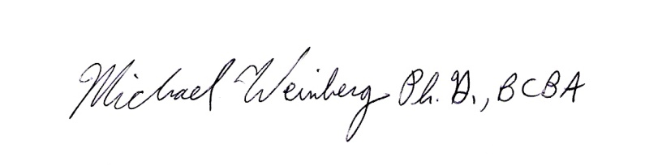
Respectfully Submitted by:

______________________________ 5/31/08
Michael Weinberg, Ph.D., BCBA Date
Chair, PIBA SIG

